Course

Handbook

Modern Apprenticeship: Built Environment SCQF 6/7



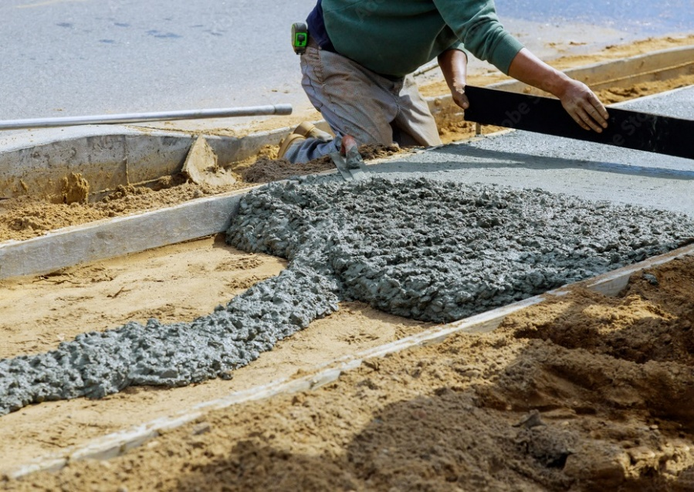

Table of Contents

Welcome and Overview 3

Key Contacts 4

Aims of your Course 5

Structure of your Course 5

Progression Routes to Further Study and Employment 6

Get Tech Ready 7

Guidance Statement on the Use of Generative Artificial Intelligence Tools 8

Embracing AI in Education 8

Student-Focused Use of AI Tools 8

Guidance for Responsible Use 8

Age Restrictions 9

Recommendations for Research Students 9

For more current information 9

Personal Support Whilst Learning 10

Your PDA 10

PDA Time 11

Recommended Texts / Reading List 12

Lost Property 12

Opening Times 12

References 12

# Welcome and Overview

As you begin your student experience with us, you are entering a supportive and vibrant learning community built on mutual respect and collaboration.

At UHI Inverness we are committed to providing you with the resources you need to thrive academically and personally. Our Student Support Centre and The Bothy, our drop-in workshop and support venue, are open every weekday to assist you every step of the way. They are both located behind reception at the Inverness Campus.

We also offer cost-of-living support such as our foodbank, The Larder, and our free toiletries cupboard, The Cubby, which can both be found in the atrium. Additionally, we provide three free car parks and bike storage at the Inverness Campus and there are public service bus stops in our grounds.

As part of our commitment to create a healthy and inclusive environment, we are proud to maintain a smoke free campus. Second hand smoke is harmful to health and the impact of second-hand vaping is not currently fully understood. Smoking and vaping are only permitted in the smoking shed by car park one.

Please refrain from smoking at entrances, exits, and approaches to our campus buildings and uphold our clean and welcoming atmosphere. Cigarette butts should be disposed of in the cigarette bins provided. Vaping devices should be disposed of safely in special recycling bins and should not be placed in general waste bins or left on the ground.

NHS Highland has a team of specialist advisers to support individuals who want to stop smoking or vaping. Their details can be found below:

**](https://www.smokefreehighland.scot.nhs.uk/) [**Smok**](Smok)[**e Free Highland**](https://www.smokefreehighland.scot.nhs.uk/)[**https://www.smokefreehighland.scot.nhs.uk/**](https://www.smokefreehighland.scot.nhs.uk/)

**](mailto:nhsh.stopsmoking@nhs.scot)** [**nhsh.stopsmoking@nhs.scot**](mailto:nhsh.stopsmoking@nhs.scot)

[**01463 704619**](http://01463704619/)

**[](https://www.instagram.com/nhshsmokefree/)** [**nhshsmokefree**](https://www.instagram.com/nhshsmokefree/)

We are excited to welcome you to UHI Inverness and look forward to supporting you throughout your time with us.

Please read the [Welcome Guide](https://www.inverness.uhi.ac.uk/t4-media/one-web/inverness/studying-at-ic/new/UHI_Inverness_Applicant-Guide-2023-web.pdf) and [Key Information Booklet](https://www.inverness.uhi.ac.uk/t4-media/one-web/inverness/UHI-Inverness-Key-Information-Booklet.pdf). There is a variety of information contained in these guides, some of which will be of greater relevance to you as you work through the course. They are there to dip in and out of when you feel you need a bit more information.

# Key Contacts

|  |  |
| --- | --- |
| Your Personal Development Advisor (PDA) is: | Mairi Stewart |
| Icon  Description automatically generatedYour PDA’s phone number is: | TBC |
| Icon  Description automatically generatedYour PDA’s email address is: | Mairi.stewart.ic@uhi.ac.uk |
| Icon  Description automatically generatedOur Student Support phone number is: | 01463 273208 |
| Icon  Description automatically generatedOur Student Support email address is: | [Student.Support.ic@uhi.ac.uk](mailto:Student.Support.ic@uhi.ac.uk) |
| Icon  Description automatically generatedOur Learning Support Team email address is: | [Additionalsupport.ic@uhi.ac.uk](mailto:Additionalsupport.ic@uhi.ac.uk) |
| Icon  Description automatically generatedOur Wellbeing Team email address is: | [Wellbeing.ic@uhi.ac.uk](mailto:Wellbeing.ic@uhi.ac.uk) |
| Icon  Description automatically generatedOur Library phone number is: | 01463 273248 |
| Icon  Description automatically generatedOur Library Team email address is: | [Library.ic@uhi.ac.uk](mailto:Library.ic@uhi.ac.uk) |
| Icon  Description automatically generatedCampus Reception | 01463 273000 |
| Icon  Description automatically generatedThe Bothy email address is: | [Thebothy.ic@uhi.ac.uk](mailto:Thebothy.ic@uhi.ac.uk) |
| Icon  Description automatically generatedHighlands and Islands Student Association | [Hisa.inverness@uhi.ac.uk](https://myuhi.sharepoint.com/sites/ic/centraladministration/Shared%20Documents/Miscellaneous/Archive/Course%20Handbooks%202021-22/Business,%20Computing%20%26%20Hospitality/Hisa.inverness@uhi.ac.uk) |

# Aims of your Course

The specific aims of your course are:

* Enjoy learning!
* Identify personal strengths and areas for development.
* Work towards the following themes of study – Care for Self; Care for Others; and Care for the Community.

# Structure of your Course

The units you may study are as follows:

|  |  |  |  |
| --- | --- | --- | --- |
| **Unit Code** | **Unit Title** | **Credit Value** | **Semester** |
| H66045 | Domestic Building Services | 1 | IN12 |
| H65X46 | Construction Technology: Groundworks and Substructure | 1 | IN12 |
| H65Y46 | Construction Technology: Superstructure and Finishes | 1 | IN12 |
| H65V46 | Computer Aided Drafting: An Introduction | 1 | IN12 |
| H66G45 | Construction Calculations | 1 | IN12 |
| F3JB11 | Construction Materials: An Introduction | 1 | IN12 |
| F3JM12 | Construction Site Surveying: An Introduction | 1 | IN12 |
| H66946 | Health and Safety in the Construction Industry | 1 | IN12 |
| H65S46 | Built Environment Project | 1 | IN12 |
| H66D46 | Sustainable Design for Architecture | 1 | IN12 |
| F3J612 | Civil Engineering Site Work | 1 | IN12 |
| H66E45 | Drawing for Construction | 1 | IN12 |

IN1 = Semester 1 IN2 = Semester 2 IN12 = Semester 1 & 2

The units that make up this qualification are a combination of those approved by Awarding Bodies, for example SQA, or Skills register units designed to enhance your learning.

# Progression Routes to Further Study and Employment

The curriculum area map clearly shows where this programme sits within the wider curriculum area; and the future progression routes, which may be open to you after successful completion of this course.

You may wish to continue your studies and apply for a place on the Level 7 Architectural Technology HNC.

You will discuss all options and anything else with your Personal Development Advisor (PDA) during your personal interviews throughout the year and specifically when discussing progression.

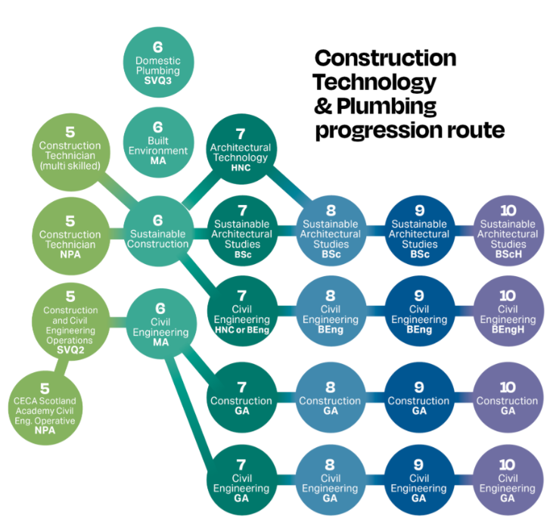

# Get Tech Ready

You'll be using lots of different digital tools and systems as a student with us.

The **New Student FAQs** on our Tech Ready [webpage](https://www.inverness.uhi.ac.uk/study/welcome/before-you-start-information-for-offer-holders-and-new-students/tech-ready/) will direct you to important information about our IT systems and the actions you need to take to become ‘tech ready’ prior to and in the early weeks of your course.

As a UHI Inverness student, you will be given a **Microsoft 365 account** for the duration of your studies, providing you with **Outlook** for e-mail, **OneDrive** for cloud storage, and access to other MS 365 applications like Word, Teams, Excel and PowerPoint. You can choose to download these apps onto your personal devices.

[**UHI MyDay**](https://myday.uhi.ac.uk/dashboard/student_home)is our student portal, designed to enable easy navigation to our various services by linking them all in one place and displaying the links as visual tiles. UHI MyDay can be accessed by going straight to myday.uhi.ac.uk from any online device. You can also download the UHI MyDay app from the Apple App or Google Play stores.

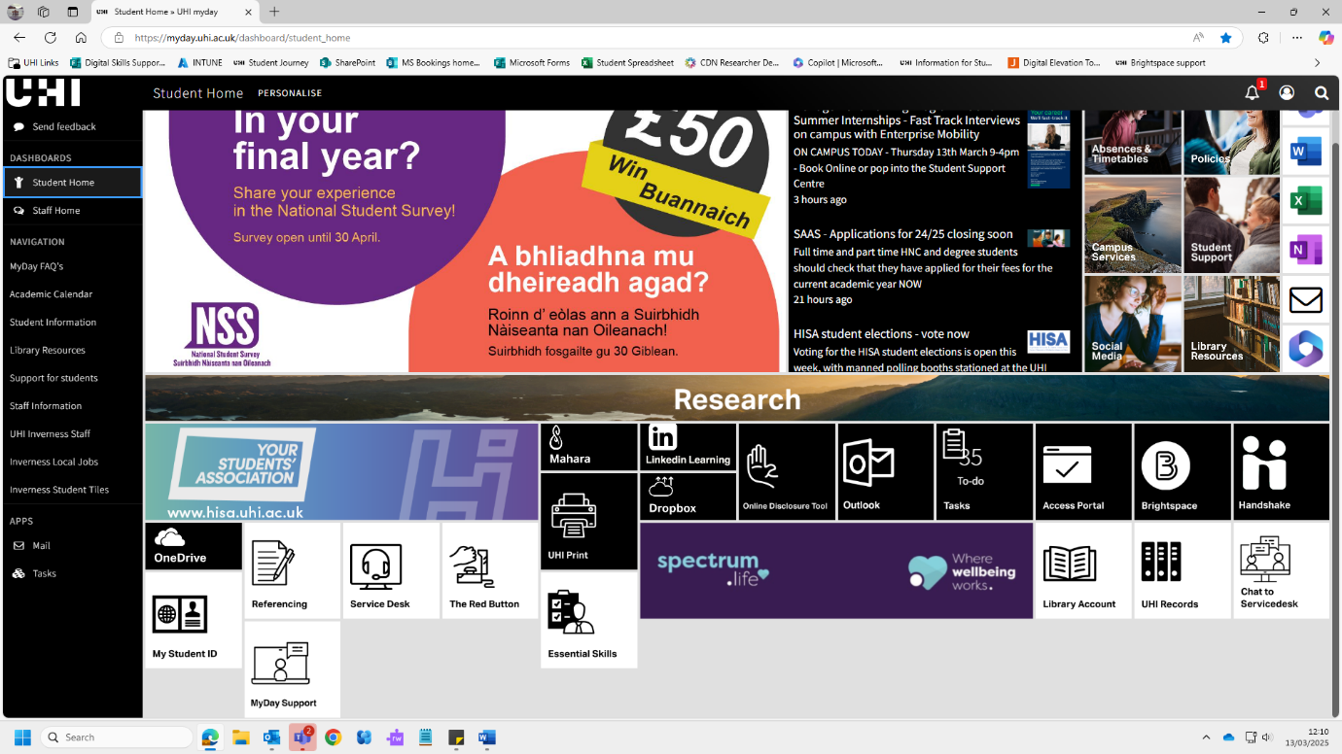

*A screenshot of the UHI MyDay Student Home page*

Key tiles on UHI MyDay include Outlook, OneDrive, and the other MS 365 web apps, plus **UHI Print**, the **My Timetable** and **Absence reporting** tiles, **My Student ID**, and **Brightspace**.

[Brightspace](https://brightspace.uhi.ac.uk/d2l/home/147326) is our virtual learning environment (VLE). Brightspace is where you will find your course materials, such as assignment briefs, discussion boards, access to remote live lectures, and session recordings. Brightspace also hosts our student support resources within a unit named ‘The Bothy’.

# Guidance Statement on the Use of Generative Artificial Intelligence Tools

## Embracing AI in Education

At UHI Inverness we believe AI tools such as, Copilot by Microsoft Office and ChatGPT, by Open AI can make learning more exciting, spark creativity, and support strong academic outcomes. These tools have been carefully reviewed to ensure they meet current educational standards. As technology and the role of AI in education evolve, we will continue to review and adapt our approach.

## Student-Focused Use of AI Tools

Generative AI tools are available to all students to assist with various academic tasks, including research, writing, and problem-solving. When using these tools, students are encouraged to:

* **Explore and Innovate**: Utilise AI tools to brainstorm ideas, generate content, and solve complex problems.
* **Enhance Learning**: Use AI to supplement your understanding of subjects, providing additional insights and perspectives.
* **Collaborate**: Work with peers and AI tools to create collaborative projects and enhance group learning experiences.

## Guidance for Responsible Use

To ensure the effective and ethical use of AI tools, students should adhere to the following guidelines:

Using AI in Your Course: Your lecturers will let you know if, and when you can use AI tools in your course or assessments. If AI isn’t allowed for certain tasks, other types of assessments will be used, based on the rules set by the organisation that awards your qualification.

* **Academic Integrity:** Always give credit when using content created by AI—*but only if your lecturer has said it's okay to use it for your studies*. Don’t copy or pretend AI-generated work is your own. Use AI to support your learning and help you improve, not to do the work for you.
* **Critical Thinking**: AI can be helpful, but it’s not always right. Think for yourself, double-check the facts, and make sure the information makes sense and matches what you’re learning.
* **Privacy and Data Protection**: Respect privacy policies and data protection regulations. Do not input sensitive personal information into AI tools.
* **Confidentiality of Course Materials**: Students must not upload or input course materials, including assessment briefs, and questions, into AI tools.

## Age Restrictions

Generative AI tools are available to students aged 18 and above. Younger students may use these tools, which is for educational purposes only, and with parental consent. To ensure inclusivity, lecturers demonstrate these tools in class, allowing students who do not meet the age requirements to collaborate in groups and benefit from their capabilities.

## Recommendations for Research Students

Research students are encouraged to make use of AI tools; however, we strongly recommend starting with our comprehensive library resources. The library offers access to a wide range of books, journals, and expert research support, providing a solid foundation for academic inquiry. Engaging with these resources first ensures a well-rounded and informed approach before incorporating AI tools into their research process.

## For more current information

For the most up-to-date information on how AI tools will be used with our students, please refer to our **UHI Generative AI Policy** which can be found on this page of our website [About us - Publications](https://www.inverness.uhi.ac.uk/about-us/publications/#d.en.258390). It includes student guidance on when and how to use AI tools (only when directed by a lecturer), how to reference when using AI tools, and how to use them responsibly. There are also helpful examples of what good, ethical use looks like. While AI can support your studies, it’s important to start with reliable sources when doing research.

We ask students to take time to review all this information during induction, so they feel confident and ready to make the most of these tools during their time here at UHI Inverness.

# Personal Support Whilst Learning

Congratulations on taking a brave step onto a new pathway to learning!

We understand that throughout the course of your learning journey you may experience personal difficulties or life events which make studying more challenging. Our aim is to offer the care, support and guidance required to help you achieve your goal of successfully completing your studies.

If you are studying full time at SCQF Level 6 or below (Further Education **FE** level) you will be assigned to a **Personal Development Advisor** **(PDA).**

Your **PDA** should be **your first point of contact** for any support needs, queries or concerns you may have.

# Your PDA

We have a team of Personal Development Advisors (PDAs) who will be available to provide advice and guidance to support your personal development while you study with us. The PDA cannot provide academic support but is a focal point for pastoral care and will work in partnership with your academic teams to support you whilst you study.

Your PDA is Mairi Stewart

If you need to see your PDA during College hours, you should make an appointment via email or, in an emergency, on the mobile number provided in this handbook or via the Student Support Centre.

General student support will also be offered through the Student Support Centre, which is open from 0830 to 1630, Monday to Friday, at Inverness Campus.

**Your PDA can be contacted on:**

01463 273 208 or Mobile: TBC

Mairi.stewart.ic@uhi.ac.uk

If your PDA is not available, you can contact our Student Support team Student.Support.ic@uhi.ac.uk 

# PDA Time

You will be scheduled to have specific time with your PDA throughout the course of the year. It is very important that you attend these sessions as they are designed to help you manage your wellbeing and ability to study effectively.

Sessions could include:

* Induction and orientation information
* Team building activities
* Wellbeing and resilience tools
* Coping with stress strategies
* Employability, careers advice and preparation
* Finance and budgeting information, support, and guidance

Your PDA can also help you with a wide range of other concerns you may have such as:

* Attendance and attainment concerns
* Course information and choices
* Finance – funding support, applying for hardship funds, if required
* Help filling in forms – course and funding applications
* Accommodation – help and advice on where to look
* Childcare information – local nurseries
* Progression after your course – What to do next and where to look for help and support

Your PDA can also refer you to more specialist services for wellbeing, counselling, general and additional support for learning, funding, welfare needs and additional help and guidance for managing your transition into student life.

This list is by no means exhaustive. Your individual needs are important to us, whatever the situation, we will listen and try to help.

If your PDA is not available, you can drop into the Student Support Centre behind reception at the Inverness campus and the team will aim to provide the answers you need or find someone who can.

**The Student Support Centre is open from 0830 to 1630, Monday to Friday.**

Alternatively, you can contact us –

  01463 273208

[Student.Support.ic@uhi.ac.uk](mailto:Student.Support.ic@uhi.ac.uk)

# Recommended Texts / Reading List

There are no set recommended texts for this course, but your tutors may advise further reading pertaining to individual subjects.

You can take out 15 books at a time from the Library and there is a drop-box and in the Ground Floor Atrium where you can leave books if the Library is closed.

Lost Property

Lost property can be handed in to the reception desk at the Inverness campus or Balloch campus. Items such as clothing, bags shoes will be held for **one month** only. After such time these will be sent to local charities. Items such as earphones and water bottles will be destroyed after **one month.** Valuables items (passports, driving licences, mobiles, purses, wallets, bags and jewellery) will be taken to the Police on a **monthly** basis.

**Bank cards** are **not** considered valuable and will be kept for **one** week before being destroyed by the Estates Team or our Data Protection Officer, who will shred on our behalf.

Items containing food or drink will be disposed of immediately.

# Opening Times

Opening times can be viewed on our webpage. Please select the relevant campus:

[Study - Our campuses (uhi.ac.uk)](https://www.inverness.uhi.ac.uk/study/our-campus/)

# References

**Useful information about UHI Inverness**

Includes strategies, publications and Student Code of Conduct

[About us - Publications (uhi.ac.uk)](https://www.inverness.uhi.ac.uk/about-us/publications/)